Trafford Children’s Therapy Service
EARLY YEARS - GETTING READY TO MOVE, SIT AND BALANCE

Getting ready to move and sit and balance

In order to be able to sit still and move around for important activities like playing we need good body strength and body control. We call this “postural-motor control”. The joints of the body need to be stable before the hands can be free to focus on activities like drawing etc.

The following activities will help your child to improve their ability in these areas.

Strengthen the back of the body

- Prone Extension: lying on tummy, lift head and arms up and fly like a superman

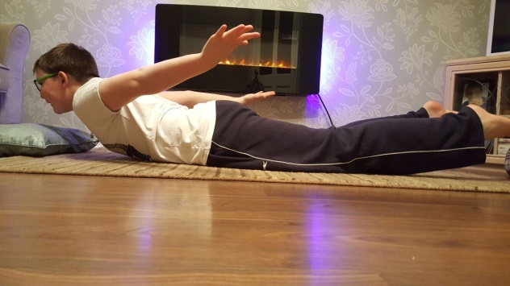

Play with jigsaws and games in this position with arm out in front

Strengthen the front of the body

2. Supine flexion: lying on back, curl head and legs up into a ball with arms crossed in front
of chest
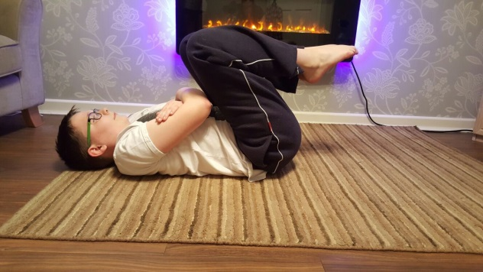

Activities where you need all parts of the body to work together
- Playground climbing equipment e.g. Monkey bars, swings, climbing frames
- Crawling through obstacles and tunnels
- Jumping on a trampoline
- Narrow space activities i.e. heel-toe/tiptoe walking along a line, balancing along balance beam

- Shoulder Strength: Activities on hands and knees, play with cars and trains
- Activities with hands above head, washing car, walls, drawing paper on wall
- Wheelbarrow activities: static and dynamic posture. Make sure that there is no dip in the child’s back and straight back should be maintained at all times
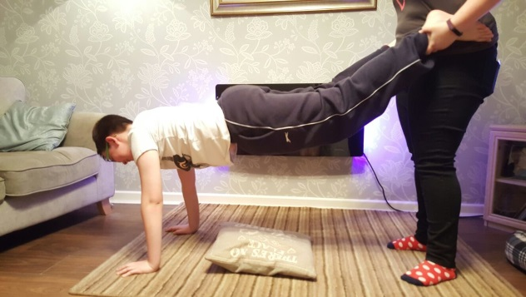

Crab walking: forwards, backwards, sideways
Animal Walks: see crab walk below
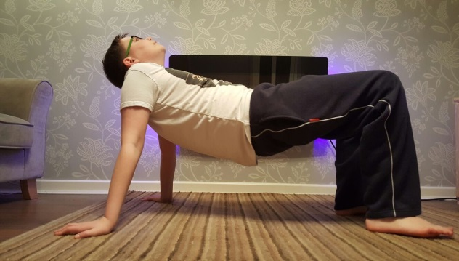

Some activities to encourage balance

- Jumping or hopping onto pavement cracks/ squares and puddles.
- Walking on small walls
- Gym trails in the park
- Climbing frames
- Walking tip-toes along a line
- Rough and tumble play
- Soft play activities
- Walking on large stones

