Toolkit for Trafford’s Love Your Liver Campaign through January and February 2026
In this toolkit, we explain why we produced this campaign and who has been involved in designing it. We also provide wording and instructions on how to use the designs.

What is the campaign about?
Liver disease usually has no symptoms in the early stages and around three quarters of people are currently diagnosed with advanced liver disease when it is too late for effective treatment or intervention. 90% of liver disease is preventable.
We are launching a new campaign to help people know more about what liver disease is, how to reduce their risks of developing it and how to love their liver.
What are we asking?
We are asking for support in promoting these messages through:
- Displaying our posters and flyers
- Sharing our posts on social media for 3 Fridays across the end of January and beginning of February
- Including our campaign in your existing communications.
The campaign will run throughout January and February, when people may feel more inclined to make healthy lifestyle changes.
Campaign details
We are focusing on 3 main themes to help people love their liver:
- Know your risks - Find out if you’re at risk of liver disease by doing our simple Love Your Liver screener – it only takes a few minutes.
- Healthy eating – British Heart Foundation has a quick quiz to help you find out if you have a healthy diet.
- Be drink aware – The Drinking Check is a free, confidential tool which requires you to answer up to 10 short questions on your drinking habits and behaviour to understand your level of risk from drinking alcohol.

Why have we chosen to promote this campaign?
Suzanne lives in West Trafford. Suzanne’s mum Christine sadly died because of complications resulting from fatty liver disease in January 2025 following a very short period of illness. Suzanne wants to spread the message about the importance of looking after your liver in easy ways. She got in touch with one of our local Councillors, Cllr Jo Harding and we met to plan this campaign.

Toolkit list of assets – January 2026
Asset description | Thumbnail of design | Instructions for how to use the asset
Know your risks/what is liver disease social media graphic | 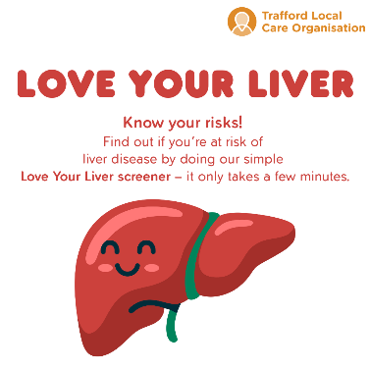 | Social media post date: 23/01/26  Please use this wording when you post:  Know your risks 🧡  Do you know if you’re at risk of liver disease?  Take our Love Your Liver screener – it’s quick, simple, and only takes a few minutes to complete.  Understanding your risk is the first step to protecting your liver.  👉 https://britishlivertrust.org.uk/at-risk-screener/  #LoveYourLiver  Twitter/X - @LiverTrust  Facebook - britishlivertrust  Insta - british_liver_trust
Cutting down on alcohol social media graphic | 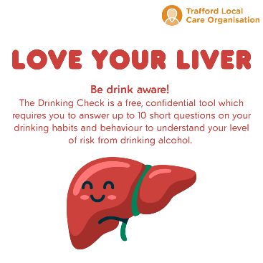 | Social media post date: 30/01/26  Please use this wording when you post:  Be drink aware 🍷  Alcohol can have a big impact on your liver – do you know your level of risk?  The Drinking Check is a free, confidential tool with just a few short questions to help you understand your drinking habits.  Take the check and stay informed.  👉 https://www.drinkaware.co.uk/tools/drinking-check/#/overview  #LoveYourLiver  Facebook - MyDrinkaware  Insta - drinkaware_trust
Eating more healthily social media graphic | 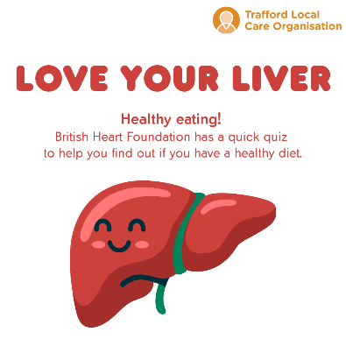 | Social media post date: 7/02/26  Please use this wording when you post:  Healthy eating 🥦  A healthy diet supports a healthy liver ❤️  Not sure how balanced your diet is? Take the British Heart Foundation’s quick quiz to find out and get tips to improve your eating habits.  Small changes can make a big difference.  👉 https://www.bhf.org.uk/informationsupport/heart-matters-magazine/nutrition/balanced-diet-quiz  #LoveYourLiver  Twitter/X - @TheBHF  Facebook - bhf  Insta - the_bhf

